PROXIMITY:

# Principle: ****It****comments that things close together are likely to be perceived as part of the same group sharing equivalent functionality or features.

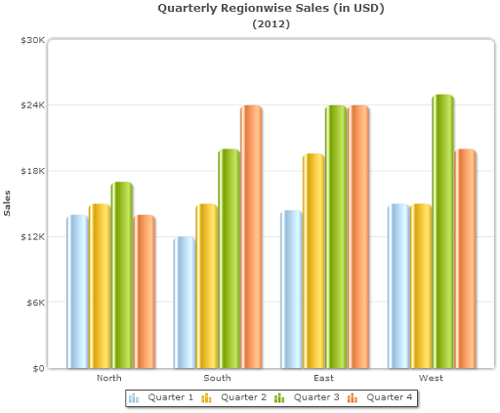  
**ABOUT GRAPH:**

The X-axis of the graph is having the north, south, east and West regions and in Y-axis it has the respective sales (USD)

It shows the proximity of regions we can see the four bars and the changes happening in 4 quarters relatively with sales.

CLOSER:

# Principle: The human eye tends to add any missing pieces of a similar structure. When faced with imprecise entities that seem to be insufficient.

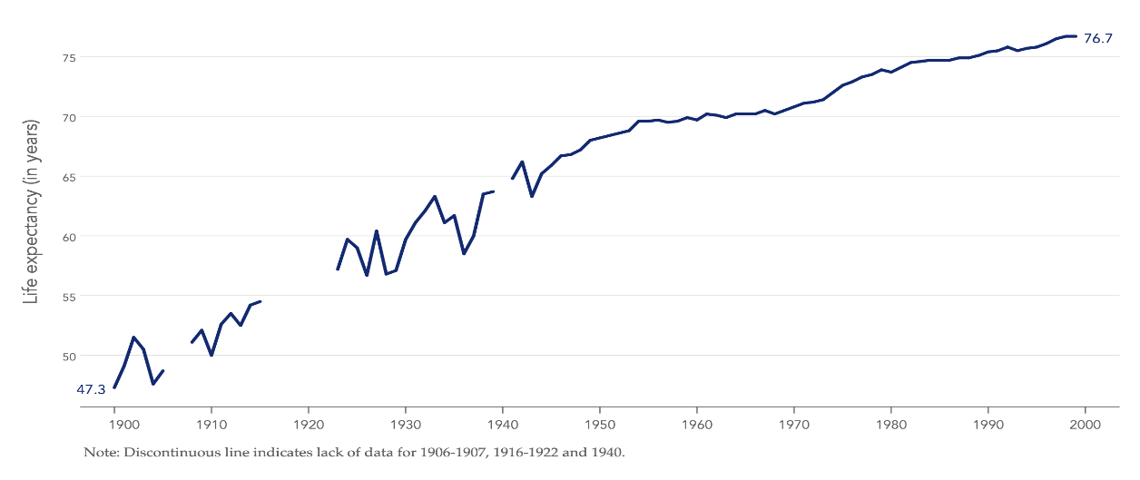

**ABOUT GRAPH:**

The X- axis is showing the years and Y- axis shows the life expectancy(years)

# With relation to the development of the average US male's life expectancy from 1900 to 2000. Consider that for the years 1906–1907, 1916–1922, and 1940, we have insufficient or poor-quality data. A typical data graph with a discontinuous chronology would then resemble this.

SIMILARITY:

**Principle**: We use various shades to distinguish series in a graph, using the principle of similarity to group items that have the same exact color, shape, and path.

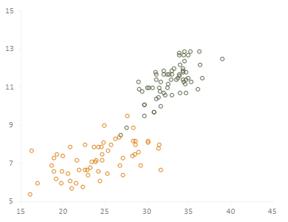

**ABOUT GRAPH:**

Every data point indicates a county, and the state is color-coded. As we can see, there is virtually no overlap as each of the two states has a unique shape.

# ENCLOSER: We sense things as belonging to a class when they are enclosed in a manner that makes a frontier or frame around them.

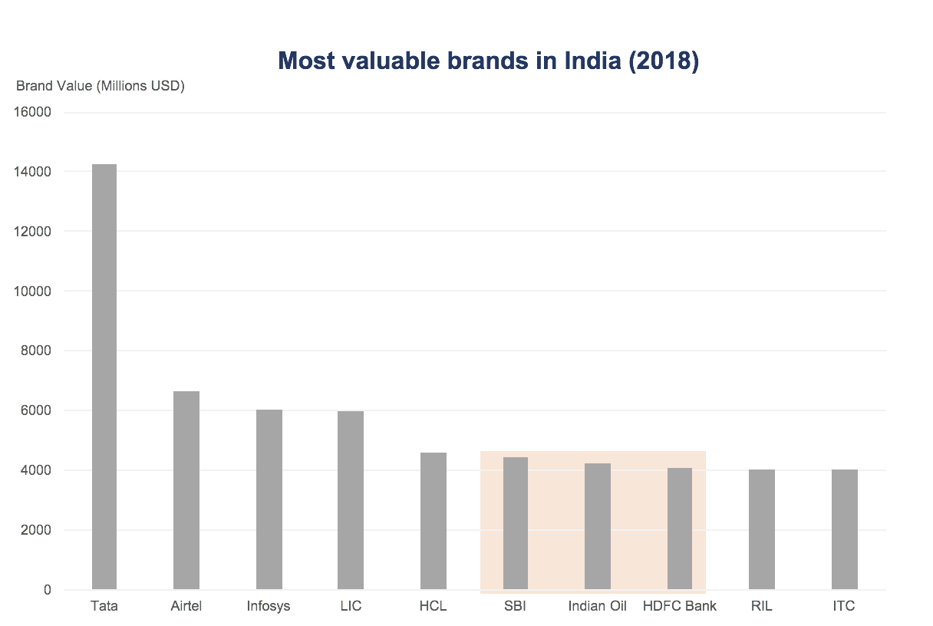

**ABOUT GRAPH:**

The three bars that share the same hue appear to be a group of three. This is because our senses see entities with a framework or limit as a group. Use this approach to attract the audiences eye to a certain group of items in your chart.

CONTINUITY:

# Principle:  Our tendency is to see figures as continuous to the greatest extent feasible.

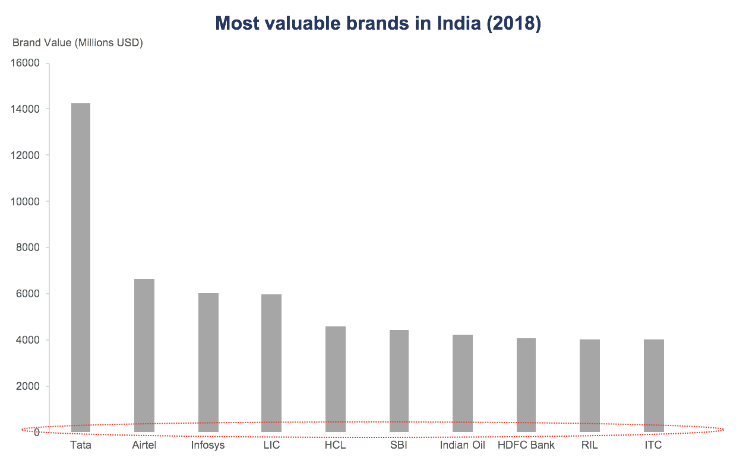

The above plots show the continuity principle by they have same base line but they don’t use the axis.

FIGURE AND GROUND:

**Principle**: **Our visual environment is typically divided between figure and ground. Ground serves as the background while Figure is the visible thing in our field of vision.**

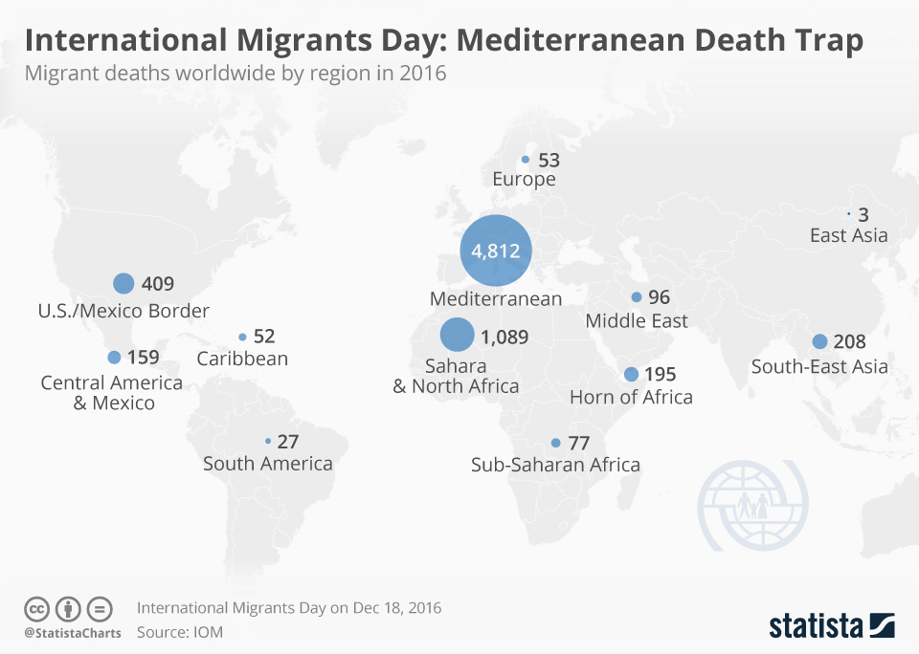

The figure on the graph is made by the blue bubbles, that are distinctive and grab our attention. The background map then comes into clear perspective.

Depending on the contrast between the two, Figure and Ground can sometimes be used alternatively.

The Figure Ground law can also be used to select the color of a chart's background image. It's important to choose a background color (ground) that won't distract from the chart.

SYMMENTRY:

We plot male population data to the left (negative x values) and female population data to the right when creating a population pyramid. Stronger than two independent charts, this results in a pyramid-like shape.

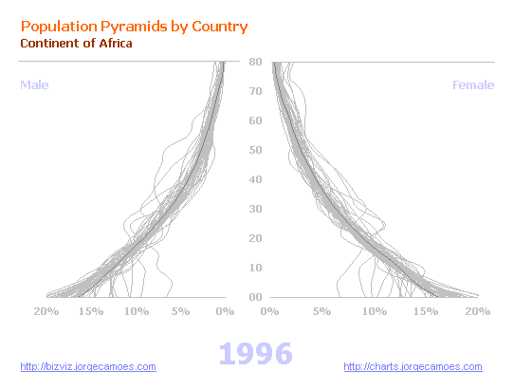

FOCAL POINT:

The user is drawn to the focus point because it stands out from the other objects in the display, catches his attention, and encourages him to investigate more of it. Let's review the "Sales by Salesperson" chart from earlier. (By now, you're probably tired of looking at this chart!) Say that you want James (a salesperson seen in the our chart) to be highlighted for some reason.

